**1** Fill in the gaps:

**a)** An ionic bond occurs when metals _____________ electrons to become positive ions. Non-metals ____________ electrons to become negative ions. They do this in order to have the same electronic configuration as elements in Group _____. (3)

**b)** On the picture below, draw an arrow to show how the electron is transferred to form an ionic bond. (2)

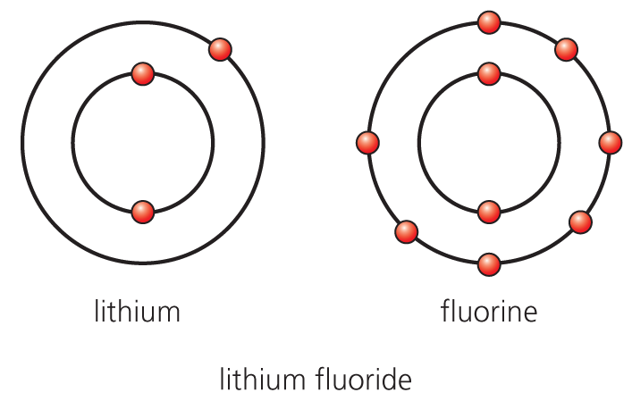

**c)** Lithium fluoride has a melting point of 845°C. Explain this high melting point in terms of the structure and bonding in lithium fluoride. (3)

**d)** The following are the charges on various ions:

|  |  |
| --- | --- |
| **Metal ions** | **Non-metal ions** |
| Na+ | Cl− |
| Mg2+ | O2− |
| Al3+ | CO32− |
|  | OH− |

Use the charges above to give the chemical formula of the compounds named below. (6)

**i)** Sodium chloride

**ii)** Magnesium choride

**iii)** Sodium oxide

**iv)** Magnesium carbonate

**v)** Magnesium hydroxide

**vi)** Aluminium carbonate

**2**

**a)** What is a molecule? (1)

**b)** What is a covalent bond? (2)

**c)** For the following molecules, draw a stick diagram *and* a dot and cross diagram. Only the outer shells need be shown in the dot and cross diagram. (9)

**i)** CH4

**ii)** H2O

**iii)** CO2

**d)** All these three substances have low melting points. What does this tell you about the forces of attraction *between* the particles? (1)

**e)** Another compound with a low melting point is the gas butane. The molecular formula for propane is C4H10.What is its empirical formula? (1)

**3** Polymers are long chain molecules made from the repeating units of a smaller molecule. One such polymer is polyethene.

**a)** What is the name of the monomer that makes up this polymer? (1)

**b)** If a polymer is easy to melt, is it a thermoset or a thermoplastic polymer? (1)

**4**

**a)** Explain in terms of the structure and bonding in metals why metals have high melting points and conduct electricity. (2)

**b)** The diagram shows the arrangement of particles in an alloy. Use this to explain why an alloy is generally stronger than the metals that make up the alloy when they are by themselves.

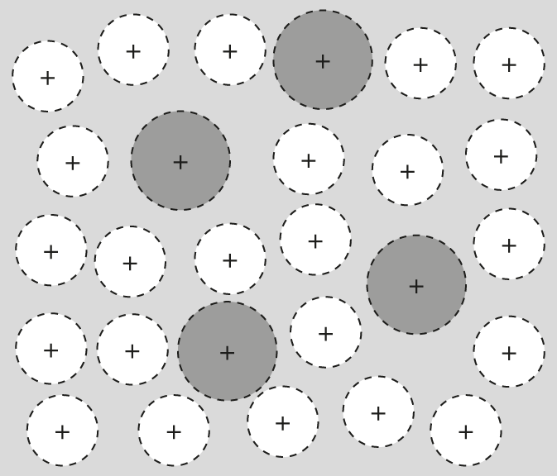

**5** Below are three forms of carbon.



**a)** What bonds do they all have between the carbon atoms? (1)

**b)** What is the chemical formula for buckminsterfullerene? (1)

**c)** Diamond and graphite are two common forms of carbon. They have very different properties.

|  |  |  |
| --- | --- | --- |
| Property | Diamond | Graphite |
| Melting point | High | High |
| Hardness | Very hard | Soft |
| Electrical conductivity | Does not conduct | Conducts |

Use the information from the table along with the diagrams to explain the physical differences between diamond and graphite. (6)

**6**

**a)** Give one use for nanoparticles. (1)

**b)** Why must we be cautious about the use of nanoparticles? (2)

**7** Fill in the gaps in the table below: (5)

|  |  |  |  |
| --- | --- | --- | --- |
| **State** | **Arrangement** | **Distance between particles** | **Movement** |
| Solid | Ordered |  |  |
| Liquid |  | Close together | Moving slightly |
| Gas |  |  | Randomly moving |

Total = 50

Answers

**1**

**a)** lose; gain; 0 or 8 (3)

**b)** Line drawn *from* outer Li electron *to* outer shell of F. (2)

**c)** Electrostatic **forces of attraction** between the **positive and negative**  ions **are very strong** and therefore a large amount of **energy is needed to separate them**. Any 3 (1 mark each). (3)

**d)** NaCl

**i)** MgCl2

**ii)** Na2O

**iii)** MgCO3

i**v)** Mg(OH)2

**v)** Al2(CO3)3 (6)

**2**

**a)** Two or more atoms chemically bonded to each other. (1)

**b)** Shared pair of electrons (2)

**c)**

**i)**

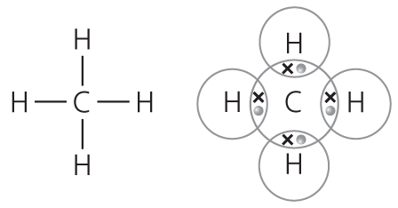

**ii)**

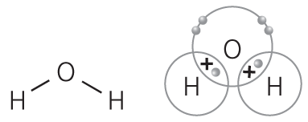

**iii)**

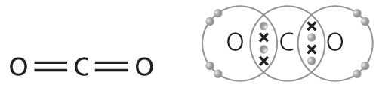

(1 mark for each stick diagram; 2 marks for each dot and cross diagram)

**d)** Weak forces (1)

**e)** C2H5 (1)

**3**

**a)** Ethene (1)

**b)** Thermoplastic (1)

**4**

**a)** Metallic bonding has a **‘sea’ of electrons** which conducts charge. These form **strong forces** that hold the structure together. (2)

**b)** **Differently sized atoms** mean the layers cannot **slide so easily**. (2)

**5**

**a)** Covalent (1)

**b)** C60 (1)

**c)**

|  |  |
| --- | --- |
| Marks |  |
| 6–5 | At least three different points well expressed |
| 4–3 | A couple of points mentioned |
| 2–1 | Not much detail |

* Both giant structures therefore high melting points.
* Graphite has layers which slide over each other.
* Therefore used as lubricant.
* Graphite has ‘free’ electrons.
* Therefore conducts electricity.
* Diamond has a giant structure.
* Each C bonded to four others with strong covalent bonds.
* Therefore very hard

**6**

**a)** Sun creams, clothing (socks), etc. (1)

**b)** They may be toxic; they can enter the blood stream. (2)

**7**

|  |  |  |  |
| --- | --- | --- | --- |
| **State** | **Arrangement** | **Distance between particles** | **Movement** |
| Solid | Ordered | **Close** | **Vibrate** |
| Liquid | **Random** | Close together | Moving slightly |
| Gas | **Completely random** | **Far apart** | Randomly moving |

(1 mark for each answer) (5)

Total = 50